Title of the book: Elementary Economics for Hong Kong Practice Book 1 (4th Edition)
ISBN: 962-397-793-x
Subject: Errata
Last updated on 12 August 2004
Page no. | Original version | Revised version
48, 50,51 | “management economies” | “managerial economies”
51 | Q17. “When a firm …is increasing.” | “When a firm …is decreasing.”
57 | “Public limited company”  ．No. of owners: 2 to ∞ | ．No. of owners: 1 to ∞
57 | “(5)_____limited company”  ．No. of owners: 2-50 shareholders | ．No. of owners: 1-50 shareholders
124 | 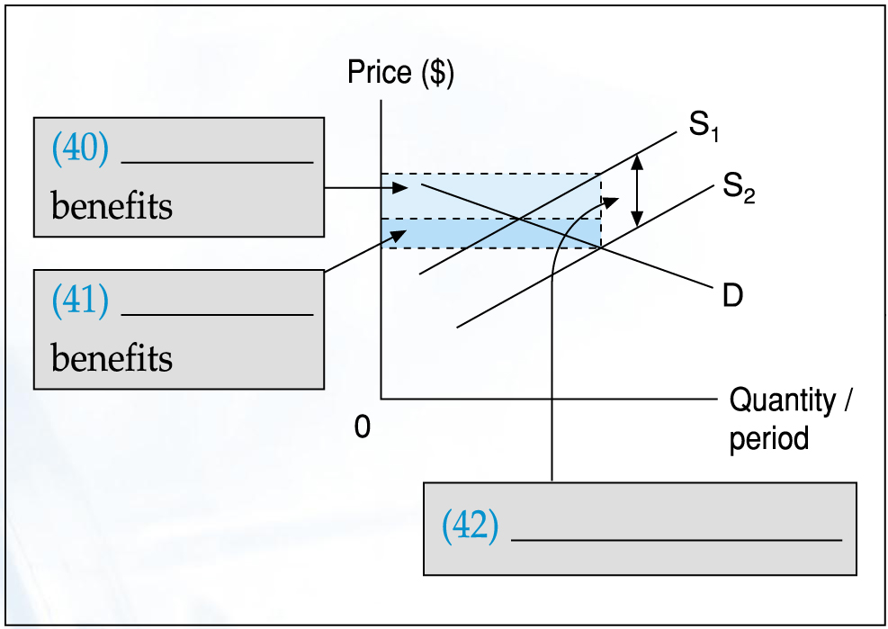
132 | New Q.3  Q.3 The government encourages the textbook publishers to publish more educational books by subsidizing them on a per unit basis. Suppose the publishers’ share of benefits on the subsidy is larger than the consumers’.  (a) State the condition that leads to this sharing of benefits. Illustrate the situation with a diagram.(6 marks)  Educational books
133 | (b) Explain, with the aid of the above diagram, the change of the publishers’ total revenue on educational books ( including the subsidy). (5 marks)

