Title of the book: Ele. Econ. for Hong Kong Practice Book 1 (4th Edition)-Answer Key
Subject: Errata
Last updated on 12 August 2004
Page no. | Original version | Revised version
18 | Concept Focus  B. (5) fixed factors  (6) variable factors | (5) variable factors  (6) fixed factors
18 | “finance economies” / “finance diseconomies” | “financial economies” / “financial diseconomies”
18, 20 | “management economies” / “management diseconomies” | “managerial economies” / “managerial diseconomies”
19 | Short Questions 1(b)  “because as shown ….to production. (1 mark)” | “because as shown ….to production. (2 marks)”
20 | The marks credited to the table of (d) (iii) change from (4 marks) to (3 marks)
38 | Revised answers to Quick Revision “Incidents” Q 2.  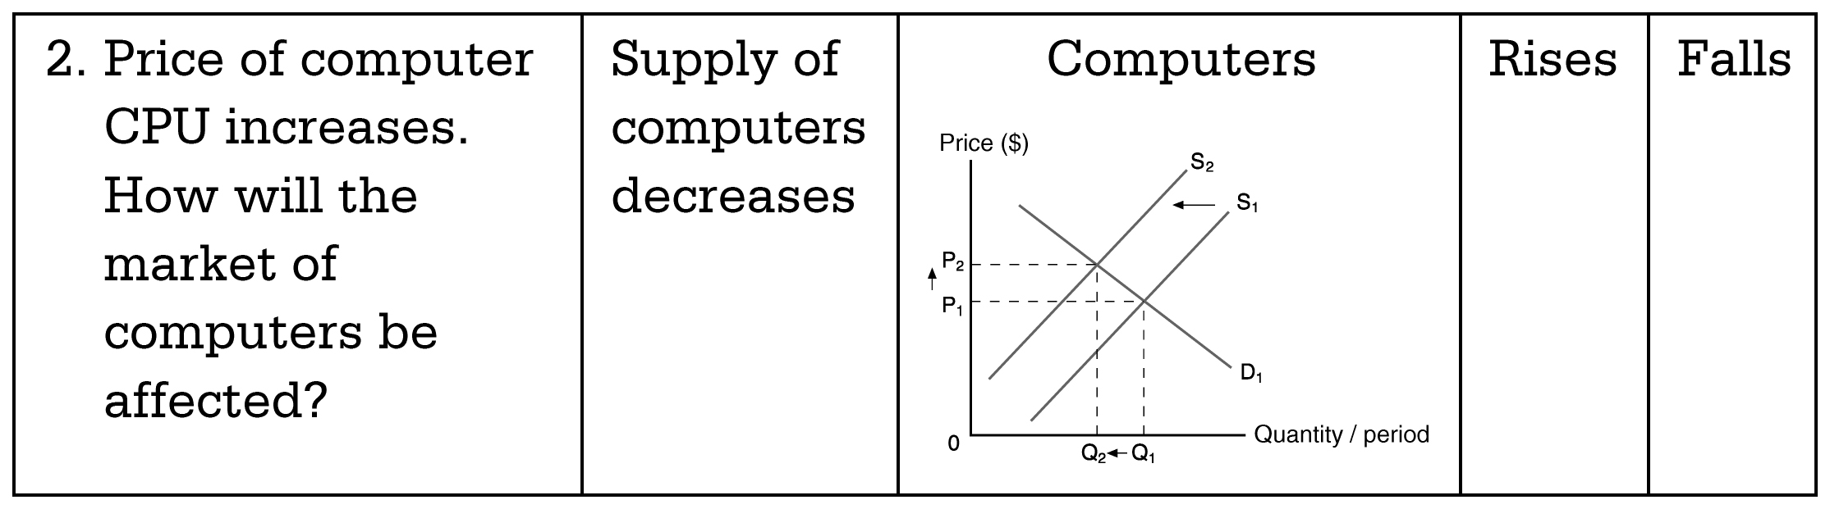

Revised answers to Quick Revision “Incidents” Q 4.
4. With both increase in demand for and supply of yo-yos, why would the equilibrium price of yo-yos decrease?

39 | Exercises--Multiple-choice Questions  12. C ＝＞ 12. B
50 | Exercises--Multiple-choice Questions  9. A ＝＞ 9. C
57 | D.  (40) Consumers’ | (40) Producers’/Sellers’
57 | (41) Producers’/Seller’s | (41) Consumers’/Buyers’
58 | (43) is smaller than / > | (43) are greater than / >
58 | (44) is greater than / < | (44) are smaller than / <
58 | (45) is equal to / = | (45) are equal to / =
60-61 | New  Suggested answers to Question 3  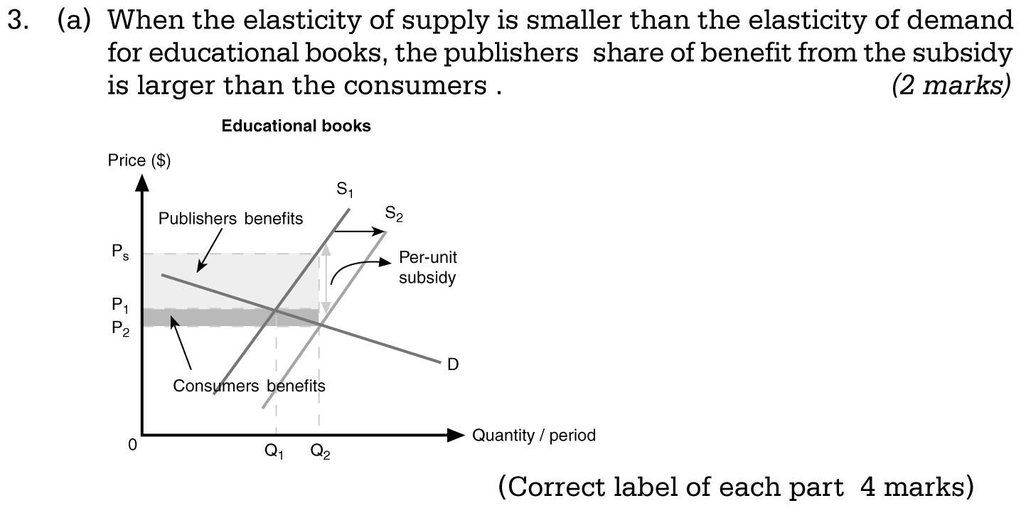
60-61 | (b) Total revenue before subsidy = P₁ x Q₁ (1mark)  Total revenue (including subsidy) = Total sales revenue + Total subsidy received (1 mark)  = P₂ x Q₂ + (P_{S}-P₂) x Q₂ (1 mark)  = P_{S} x Q₂ (1 mark)  ∴ The total revenue increased from (P₁ x Q₁) to (P_{S} x Q₂) (1 mark)

