Title of the book: Elementary Economics for Hong Kong 1B (5th Edition)
ISBN: 902-397-791-3
Subject: Errata
Last updated on 11 August 2004
Page no. | Original version |  | Revised version
1 | Example: “Jusco opened…in 1998.” |  | “Park’n Shop opened another store in Yuen Long in 2001.”
1 | New Fig. 7.2 Park’ n Shop grows internally by opening new stores  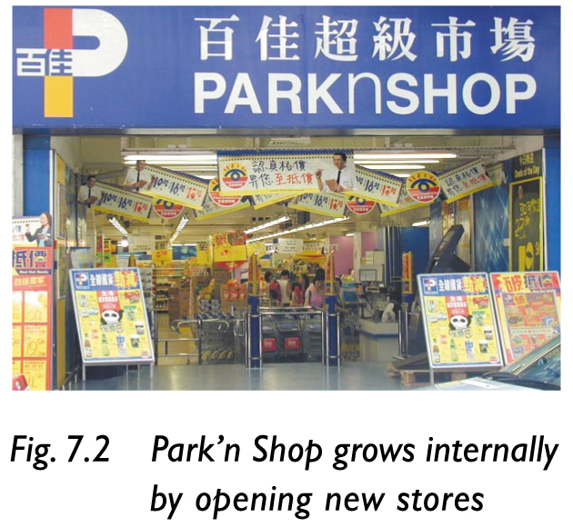
1 | Footnote no. 1 : Jusco吉之島 |  | Park’ n Shop 百佳超級市場
1 | The website of Jusco:  http://www.jusco.com.hk |  | The website of Park’n shop:  http://www.parknshop.com/cindex.html
6 | News Online 7.2, line 1:  “…with Andersen’s Hong Kong and China offices…” |  | “…with Andersen’s offices in the mainland and Hong Kong…”
9 | Point C, Examples: 2nd para., line 2:  “are both printing media.” |  | “use similar resources such as editors and printing machines.”
11 | News Online 7.4, line 2:  “…Beijing, China, with an …” |  | Delete “China”.
11, 23 | The term “in the Mainland.” |  | “in the mainland.”
16 | Before Section 7.4, add the following:  (The above discussion about methods of integration is for further study purposes. It is not included in the HKCEE syllabus.)
17 | Fig. 7.19 Monopolist harms the interests of consumers |  | Fig. 7.19 Too much integration may harm the interests of customers
19 | Dr Economics says:, 3rd para., line 1:  “…Food materials…” |  | “…Ingredients…”
19 | Dr Economics says:, 3rd para., line 3 to the last line:  “Customers may visit…more suitable.” |  | “Noodle shops and fast-food shops have different target groups of customers. Most children prefer fast food to noodles.”
21 | Text boxes of “Methods of integration”, “Takeover”, “Merger”, “Consolidation” and “Cartel” |  | Delete the mentioned text boxes.
23, 79, 85, 87, 165, 174 |  | “China” | “the mainland”
29 | 1st para., line 2  “…Alan’s quantity demanded for…” |  | “…Alan’s quantities demanded for…”
30 | Closer Look 8.1, 3rd para., line 2:  “..is the whole set of quantity demanded…” |  | “..is the whole set of quantities demanded…”
31 | Point B1, 2nd para. line 1,:  “..to sum up the total quantity demanded…at every different price, this is …” |  | “..to sum up the quantities demanded…at every different price. This is …”
34 | Section 8.3 A Definition, line 1  “…to the quantity of a good…” |  | “…to the quantities of a good…”
35 | 1st para., point (b), line 1  “…the planned quantity a seller…” |  | “…the planned quantities a seller …”
36 | Point 4, 2nd para., line 2:  “It shows the quantity supplied…a period” |  | “It shows the quantities supplied…a period”
37 | Closer Look 8.2, 1st para., line 1  “…Lucy’s weekly quantity supplied…” |  | “…Lucy’s weekly quantities supplied…”
48 | Question 2., 1st para., line 1:  “… per kg increases, please….” |  | “… per kg has increased, please….”
48 | Question 2., 2nd para.,  “Explain… an Economics principle.” |  | “Explain… an economic principle.”
51 | Point B2, line 1:  “…is a change in the quantity purchased at…” |  | “…is a change in the quantity demanded at…”
55 | News Online 9.1, line 3 to 4:  “fast-food shops stand upright. According to the statistics of the Census …” |  | “fast-food shops perform better. According to the statistics from the Census …”
61 | Closer Look 9.3, line 1:  “…in Hong Kong is one…” |  | “…in Hong Kong was one…”
61 | Closer Look 9.3, line 2:  “…there is an …” |  | “…there was an …”
62 | News Online 9.3, line 4:  “…a key factor to affect the …” |  | “…a key factor affecting the …”
71 | Closer Look 9.4, line 1:  “In summer, … hits South China,…” |  | “In summer, … hits the south of the mainland,…”
74 | News Online 9.4:  The term “Chinese lychee” |  | “the mainland’s lychee”
74 | News Online 9.4,line 3:  “…from southern China …” |  | “… from the southern part of the mainland….”
74 | News Online 9.4, line 3 to the last line:  “As the supply… with a higher demand.” |  | “ As a result, the price of lychee both from the mainland and Thailand increased.”
75 | Point C, 1st para., 2nd: point  ‧extents of… |  | ‧extent of…
75 | 2nd para., the last line:  “…different extents.” |  | “…different extent.”
76 | Closer Look 9.6 , the Title  “What Makes the Falling Price of Computers? Demand or Supply?” |  | “What Makes the Price of Computers Fall ? Demand or Supply?”
76 | Closer Look 9. 6, the last line:  “…and quantity transacted increase.” |  | “…and equilibrium quantity increase.”
87 | Question 4 (a):  “…in China due to flooding, what would the market…” |  | “…in the mainland due to flooding, how would the market…”
 | For Q 4 (a) and (c): “Chinese” |  | “the mainland’s”
 | Q.2 (b), line 1 “South China” |  | “the south of the mainland”
107 | Fig. 10.16 Some consumers are addicted to particular product |  | Fig. 10.16 Some consumers are used to particular product
107 | Point 6, 2nd para.,  “When its price… to be elastic.” |  | This para. is deleted.
107 | Point 7, “Example” line 3:  “the price of a big abalone increases,…” |  | “the price of abalones increases,…”
107 | Footnote no. 22 abalone 鮑魚 |  | abalones 鮑魚
107-108 | Fig. 10.17 is put to the bottom of p. 107 from the top of p 108
108-109 | Q10.4 is put to the bottom of p. 108 from the top of p. 109
109 | Section 10.2 A, 2nd para., line 2:  “always positive. Thus…” |  | “usually positive. Thus…”
113 | Point C 1, 2nd para., line 3:  “…in quantity supplied.” |  | “…in quantity supplied when price changes.”
121 | Section 11.1 A, line 3:  “…may intervene the price.” |  | “…may intervene in the price.”
125 | Q11.1 “Given a demand …” |  | Q11.1 “Given the demand …”
135 | Point A, 1st para., line 2:  “and demand schedule are shown in Table 11.3 (a).” |  | “and demand schedules are shown in Table 11.3 (a).”
144 | Economics Clinic, Q.1  “How to improve…taxes?” |  | “How can I improve…taxes?”
147 | Structured Questions, Q.1:  “…subsidy to the Home for the Aged.”  (a) “…service of the Home for the Aged change?” |  | “…Subsidy to the home for the aged.”  (a) “…service of the homes for the aged change?”
151 | Point 2, the 2nd last line:  “…charge the only one and the same price…” |  | “…charge the same price…”
155 | News Online 12.1, Dr Economics says, he last line:  “There is a need for…trademark registration.” |  | This sentence is deleted.
155 | News Online 12.1, The term “the Mainland” |  | “the mainland”
157 | Closer Look 12.3, 2nd point  ．“Fashions in different shops …” |  | ．“Clothes sold in different shops …”
157, 158, 160, 162 | The terms “ is under monopolistic / oligopoly” |  | “is classified as monopolistic /oligopoly”
163 | Fig. 12.14 It is difficult to enter the market of monopoly |  | Fig. 12.14 It is difficult to enter an industry monopolized by a monopolist
164 | News Online 12.5, 2nd last line:  “…users have no choice…software go...” |  | “…users had no choice…software went...”
165 | News Online 12.6, Dr Economics says:  Line 1 to line 2:  “Actually, monopoly is no good to consumers. Not only…are few choices for …” |  | “A monopolist may have done more harm than good. Not only…are fewer choices for…”
170 | Economics Clinic, Q 2, Dr Economics says,  The last para., line 1:  “…mentioned is not under perfect…” |  | “…mentioned does not belong to perfect…”
171 | Economics Clinic, Q 3, Dr Economics says:  D. “Correct. … contents and editing, which…” |  | D. “Correct. … contents and layouts, which…”
178 | The 2nd column, answers to 11.1 (c): line 3 to 4  “(perfectly inelastic demand)” |  | This is deleted.
179 | The 2nd column, answers to 11.8 (a)  In the diagram, “Buyers’ burden” |  | In the diagram, “Buyers’ benefits”

